Name : Maryam kashif

BITF24M053
PROJECT DOCUMENTATION

Ransomware Simulation & Backup Recovery System (with WannaCry Reference)

1. Introduction
Ransomware is a type of malicious software that encrypts user files and demands payment for their recovery. It is one of the most dangerous cybersecurity threats in modern computing.A well-known real-world example is the WannaCry ransomware attack, which spread rapidly across the world in 2017. It affected thousands of computers, including hospitals and organizations, by encrypting their data and demanding ransom in cryptocurrency.This project simulates a ransomware attack in a controlled environment to demonstrate:
- How files become unreadable after encryption
- How backup systems help recover data
- The project is purely educational and does not involve real malware.

2. Problem Statement
Ransomware attacks, such as the WannaCry ransomware attack, encrypt user data and make it inaccessible. Many systems lack proper backup mechanisms, resulting in permanent data loss.
This project addresses:
- The impact of ransomware on file security
- The importance of backup before attacks
- How recovery systems can prevent data loss

3. Objectives
The main objectives of this project are:
- To simulate ransomware file encryption
- To understand real-world attacks like WannaCry ransomware attack
- To demonstrate unreadable encrypted files
- To create backup before encryption
- To restore files using backup
- To highlight cybersecurity awareness

4. Methodology / Working
The system works in the following steps:

Step 1: File Input
User enters a text file name.

Step 2: Backup Creation
A backup file is created:
backup_filename.txt

Step 3: Encryption (Attack Simulation)
- XOR (0xFF) encryption is applied
File becomes unreadable (like ransomware attack)

Step 4: Encrypted File
encrypted_filename.txt

Step 5: Decryption (Optional)
Same XOR operation restores original data

Step 6: Recovery (Defense Mechanism)
Backup file restores original content
- This simulates how attacks like WannaCry ransomware attack work, but in a safe and simplified way.

5. Implementation Details
The project is implemented in C++ using file handling.

Main Program
- Takes filename input
- Creates backup
- Encrypts file
Encryption Logic
Uses XOR operation (^ 0xFF)
Converts readable data form into unreadable
Decryption Logic
Same XOR operation restores data
Backup Mechanism
Copies original file before encryption
Ensures safe recovery
WannaCry Attack:
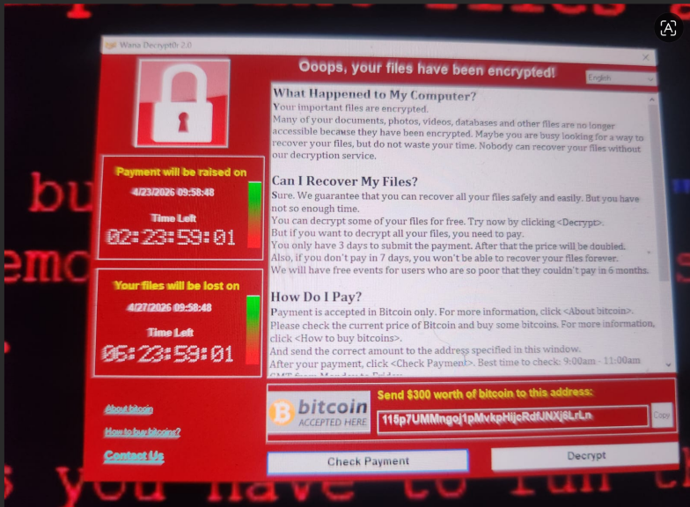
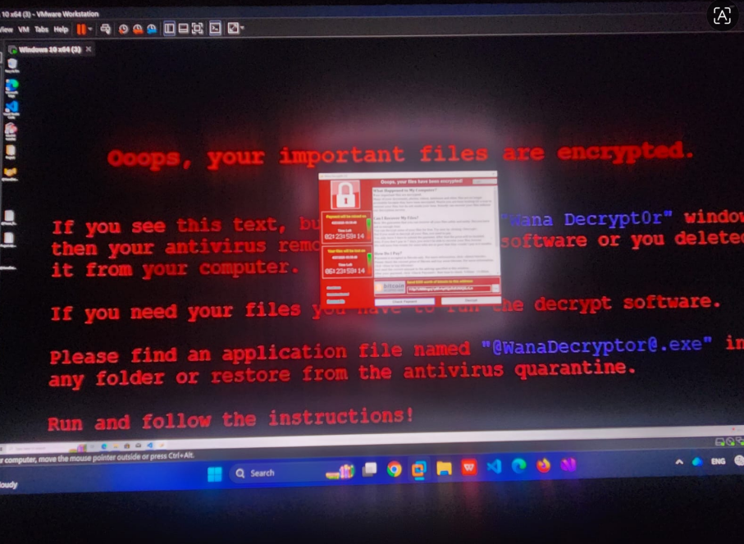

6. Results
- File successfully encrypted (unreadable)
- Backup file created before attack
- Simulation behaved similar to ransomware concept
- Original file recovered using backup
- Demonstrated both attack and defense

7. Conclusion
This project successfully simulates a ransomware attack and demonstrates the importance of backup systems.
Real-world attacks like the WannaCry ransomware attack have shown how dangerous ransomware can be. This project helps in understanding:
- How ransomware encrypts data
- Why backups are essential
- How data recovery is possible
Overall, the project provides strong knowledge of cybersecurity fundamentals and prevention strategies.

